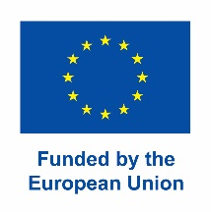

Press Release
25 July 2022

ŠKODA AUTO University involved in international consortium to expand innovation capacities
Fostering innovation, facilitating start-ups: Six universities work together

ŠKODA AUTO University (Mladá Boleslav, Czech Republic) is involved in a European consortium project as the partner of work packages on Development and improvement of entrepreneurial curricula, Development of international entrepreneurial and innovation training programs amongst others. Universities from Germany, France, Belgium, Norway, Romania and the Czech Republic, as well as a Romanian technology and innovation company, will work over the next two years to tap the innovation potential in European higher education. The main goal of the INTREPID-HEI project is to further improve the conditions for start-ups and spin-offs. The EU is funding the project with around 1.2 million euros.

"Ultimately, the aim is to increase Europe's innovative capacity and promote entrepreneurial talent in order to create sustainable growth and skilled jobs in Europe," says Marco Siegl, project coordinator from lead partner Ostbayerische Technische Hochschule Regensburg (OTH Regensburg, engl. Technical University of Applied Sciences Regensburg). OTH Regensburg has an excellent reputation throughout Germany in the areas of start-ups, innovation, training and transfer, says Prof. Dr. Sean Patrick Saßmannshausen, head of the university's start-up center. The new project now helps to gain greater visibility on the European stage and to present the Regensburg region as an internationally leading location for start-ups and innovation.

INTREPID-HEI: The acronym stands for "International Capacity Building in InNovation, Transfer and Entrepreneurship with focus on ShaRed Expertise in Higher Education Institutions". Intrepid can be translated from English as brave, courageous or fearless "and is therefore emblematic of the extremely ambitious goals that OTH Regensburg, as the project coordinator, is taking the main responsibility for achieving," says Prof. Dr. Oliver Steffens, Vice President for Research and Internationalisation of OTH Regensburg. “For ŠAVŠ, participation in the project is an opportunity to pass on its know-how in the field of cooperation with practice and at the same time to innovate existing study programs, implement other elements of entrepreneurship, start-ups and everything that supports creative thinking, innovation and reflects on the needs of the 21st century, says doc. Ing. Pavel Mertlík, CSc., the Rector of ŠKODA AUTO University. “We also consider innovation-driven research in the field of business competition and entrepreneurship to be a very important part of the project, as well as the establishment of further cooperation in education, research, and with new business partners.”

Advising founders and idea developers, internationalization and accessibility of courses, use of digital teaching and consulting methods, knowledge transfer and regional integration through broad-based events and platforms, ensuring sustainability and the long-term continuation of cooperation between the partners, the exchange of expertise as well as start-up and innovation infrastructure are the main goals of the project.

Other project partners are Ostbayerische Technische Hochschule Regensburg (Regensburg, Germany, lead partner), Université Clermont Auvergne/Clermont Auvergne Innovation Clermont-Ferrand, France), VIVES University of Applied Sciences (Kortrijk, Belgium), Høgskulen på Vestlandet (Bergen, Norway), and Universitatea "Ovidius" din Constanța (Constanta, Romania) as well as the innovation company Iceberg Data Intelligence (Bucharest, Romania).

The cooperation network emerged from the European higher education alliance "ERASMob - European Alliance on Sustainable Mobility" and the shared conviction that much of the desired expertise and experience in innovation and entrepreneurship already exists within the consortium, albeit unevenly distributed among the individual partners. By combining four thematic work packages focusing on training, innovation, start-ups and transfer, INTREPID-HEI brings this knowledge together to further improve the conditions for start-ups and innovation and to achieve European convergence.

According to Marco Siegl, plans include "effective regional and international transfer events" that will bring together training, research and technologies as well as companies. To kick off the project, the project coordinator presented the goals and content of the project at a workshop in Barcelona with an Innovation Vision Action Plan (IVAP). Prof. Dr. Sean Patrick Saßmannshausen, Dr. Pascal Gautier (Université Clermont Auvergne/Clermont Auvergne Innovation), Prof. Dr. Costin Sorici (Universitatea "Ovidius" din Constanța) and Matthias Malfrere (VIVES University of Applied Sciences) from the INTREPID-HEI project were on site and were able to network with over 220 project representatives and the contact persons of the funding agency and exchange experiences and planned project content.

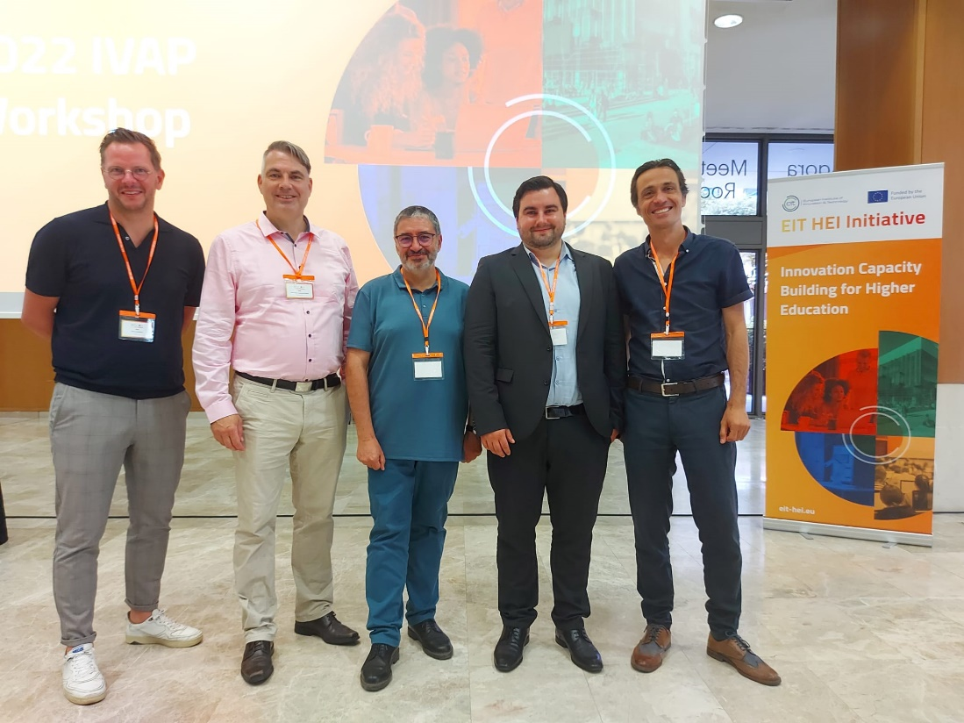

Picture: Representatives of the INTREPID-HEI project at the workshop in Barcelona (from left): Matthias Malfrere (VIVES University of Applied Sciences), Prof. Dr. Sean Patrick Saßmannshausen (OTH Regensburg), Dr. Pascal Gautier (Université Clermont Auvergne/Clermont Auvergne Innovation), Marco Siegl, M.Sc. (OTH Regensburg, project coordinator) und Prof. Dr. Costin Sorici (Universitatea “Ovidius” din Constanța). Picture: Prof. Dr. Costin Sorici (Universitatea “Ovidius” din Constanța)

